AI ASSISSTED CODING 6_5
2303A510i0
V . Harika
Batch : 30
Task 1:
Code:
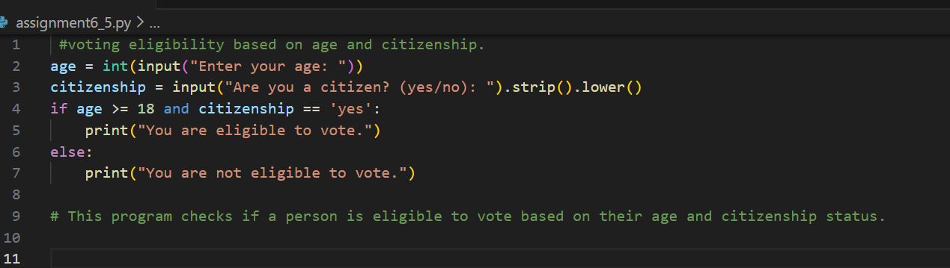
Output:
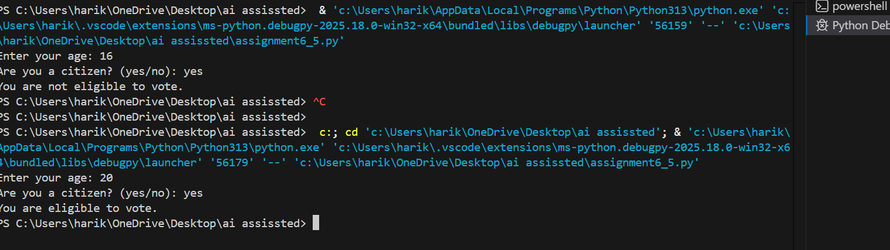
Justification: This task teaches conditional logic in Python, helping learners understand how to apply if-else statements to real-world scenarios like age and citizenship checks.

Task 2:
Code:
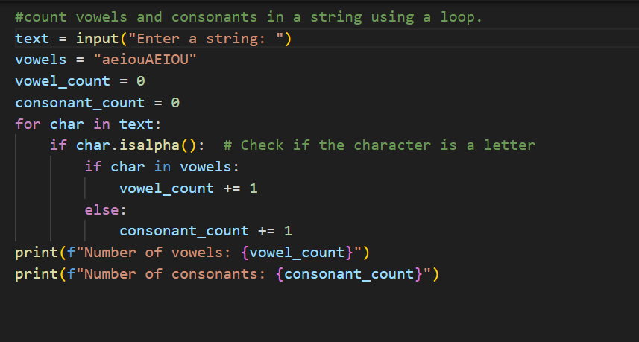
Output:
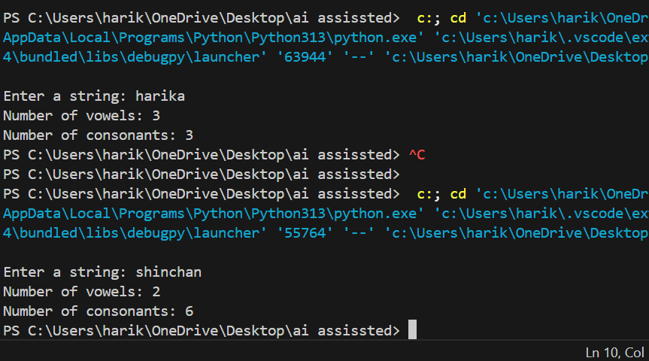
Justification: Counting vowels and consonants reinforces loop usage and string handling, building foundational skills in iteration and character classification.
Task 3:
Code:
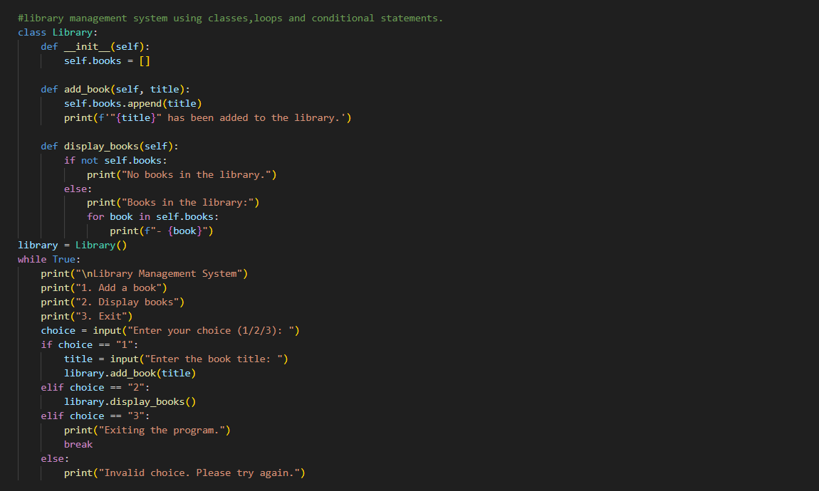
Output:
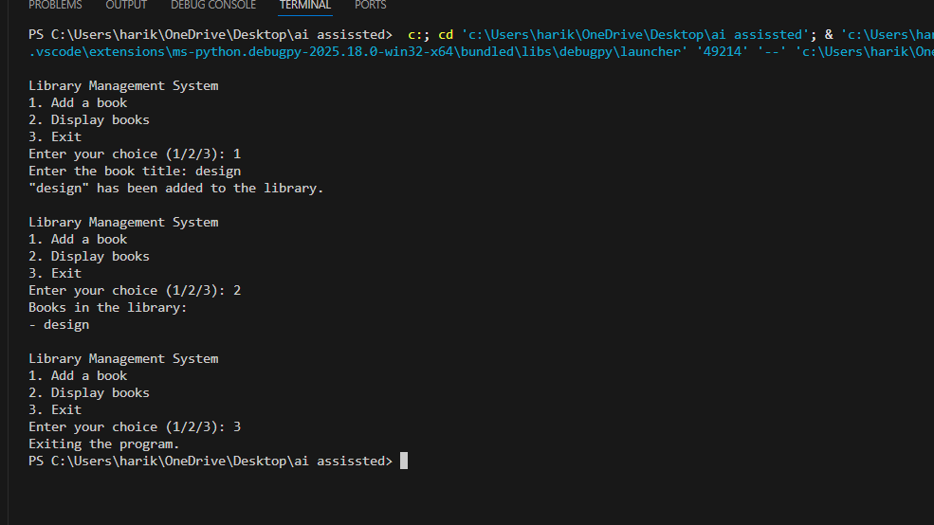
Justification: Combining classes, loops, and conditionals develops object-oriented programming skills while simulating a practical application, encouraging reflection on AI-assisted coding quality.
Task 4:
Code: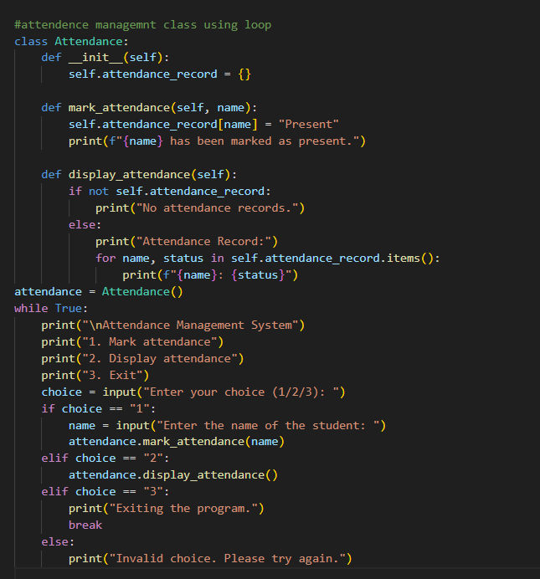
Output:
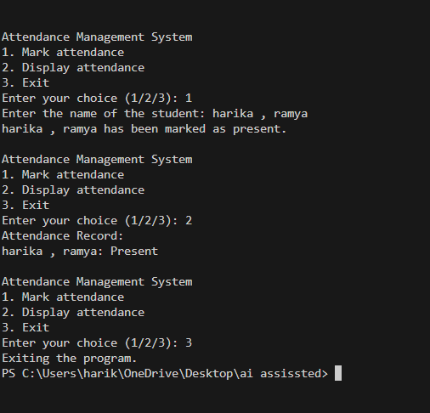
Justification: his task introduces class-based design with loops, showing how to manage and display structured data, while test cases ensure correctness.
Task 5:
Code: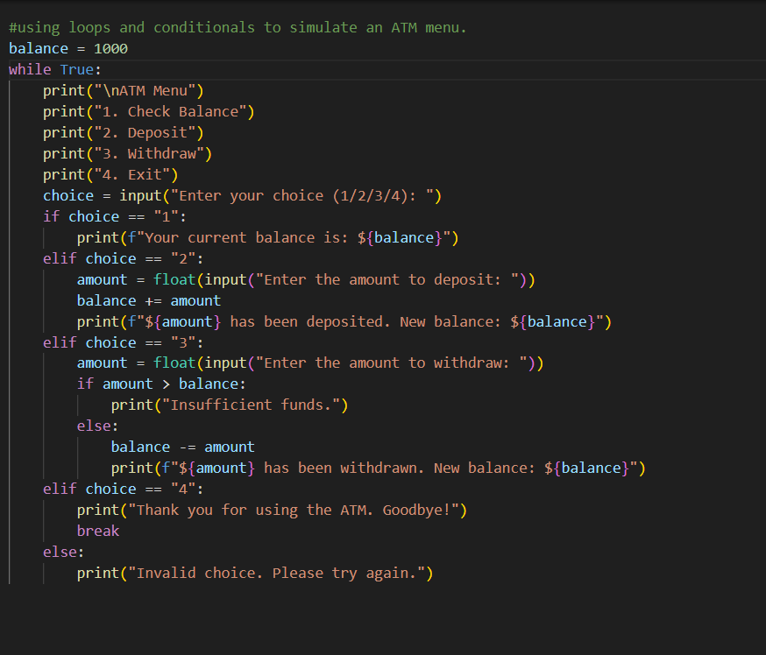
Output:

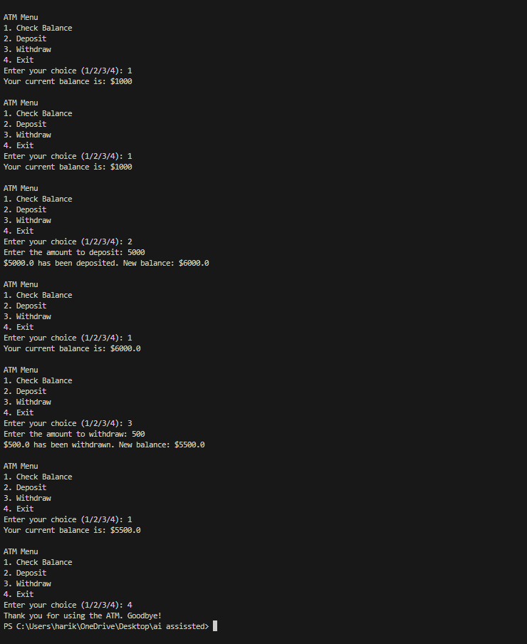
justification: Using loops and conditionals for menu navigation demonstrates interactive program design, strengthening logic flow and user input handling in Python.

